410-bore Shotgun Slug Swaging Die V-3.1

By, Stephen J. Compton

Die Construction:

Introduction:

First of all, I should explain that although I developed the basic design principles and blue prints for this swaging die I did not do the actual machining work myself. I paid a machinist friend to do the actual metal cutting work for me. There was, however, a lot of back and forth between us on the actual machining methods and materials to be used for each of the components. So, here are some quick pointers as best as I can represent them without being an actual machinist myself. First, as you will note, it is possible to produce this entire die with exception of the “Coupler” component using metal lengths cut from bolts as the raw materials. If you choose to do so, please note that my machinist who cut my second generation (V-2.0) die found that it did not work well to attempt to cut the 7/8-14 threaded “Die Body Bottom” & “Die Body Top” components out of 7/8-14 threaded bolts. Difficulties in holding the components while machining were encountered. So he used the unthreaded upper portions of longer bolts that were only threaded on the tip and then cut the threads himself as one of the last steps in producing the components. Specific pointers on each component follow.

Die Body Bottom ( Page #2 ):

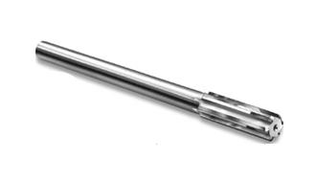
This is the most difficult component to machine. Basically a stepped internal bore with a major and minor diameter must first be cut. It is necessary to use reamers such as the one pictured below and to the right to cut the final finished surfaces of these bores rather then simply boring or drilling to ensure a quality, fine finish and ensure the bores are on size. Radial grooves from boring or drilling would make it hard to eject the finished slug from the die. In my V-2.0 die reamer sizes 0.410” and 0.348” were used to cut the final finished surface of the major and minor bores respectively. This produced a finished die where the major diameter was at the maximum acceptable diameter of 0.412” if not a hair over. Thus, when updating my blue prints for the die version 3.0 and then 3.1, which take into account lessons learned from my V-2.0 die, I suggest the use of a 0.409” size reamer on the prints to cut the major bore of this component. This should make it easier to keep the finished die within tolerance at a finished diameter that is between 0.410” and 0.412”since a 0.410” reamer produced a finished size approx. 0.002” larger.
Rifling Groove Details ( Page #3 ):

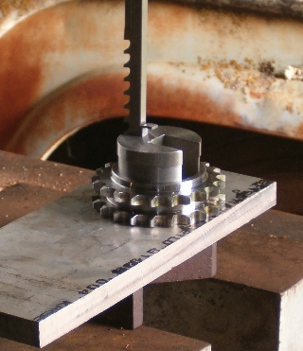
The rifling pattern is cut into the minor bore diameter upper section of the “Die Body Bottom” component using a 1/16” key-way broach with jigs and shims. As you will note the rifling grooves are arranged in a six point arrangement in 60 degree rotation steps. This is not my idea; my original V-2.0 blue prints called for an eight point set-up with 45 degree rotation steps. My machinist found it much easier to cut a six point set-up, and the resulting slugs work just fine with six rifling grooves rather then eight. I do not have a photo of the exact set-up he used to do the broaching cuts but I did find this photo on the net of how a single key-way is broached into a gear or pulley, and it is provided to the right.

Die Body Top ( Page #4 ):

The main thing to note with this component is that there is an unspecified angle between the major and minor bores which has been designated Angle – “A”. This angle is the product of the tooling used to cut the major bore and must be noted for later reference when cutting the “Extractor Punch” component. Also, do not skimp on the material used for this component, there is a very small ledge between the major and minor bores which is an unavoidable part of the swag die design and must support strong upwards compression forces transferred from the extractor punch during die use as the lead core is compressed from below.

Extractor Punch ( Page #5 ):

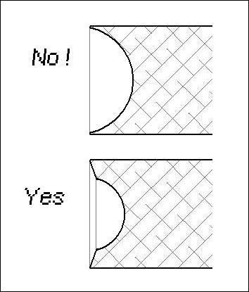
This component is rather simple. Some may be tempted to alter its bottom end shape in order to alter the nose shape of the slug produced by the die and possibly produce multiple variations to produce multiple slug nose shapes with the same die. This is certainly possible, but I would put forth two cautions. First, any change in this component that changes the nose shape of the slug to produce a nose which is longer then the one specified must be offset by shortening the rifling section in the “Die Body Bottom” component and lengthening the “Swag Punches” components by the same approximate amount in order to maintain the slugs’ aerodynamic stability. Altering the nose shape of the slug by a significant amount without making the appropriate changes else-where will result in a die that will produce slugs that could exceed a 1.5 to 1 ratio between slug length and diameter. Such slugs most likely would not stabilize in flight and would wobble or tumble instead of fly nose first which would severely affect accuracy. Secondly, if such a change is made care should be taken to ensure that the way the bottom end shape of this component is altered does not produce an outer perimeter that is too thin and fragile to withstand the high compression forces (10,000+ PSI) acting inside the die while a solid lead core is being swaged into the shape of a 410-bore slug. An example drawing to the right is provided to demonstrate what I mean.
Swag Punches ( Page #6 ):

These are also rather simple components. Two different punch nose shapes are shown, one to produce a simple hollow base slug and another to be used to produce a Brenneke style slug with attached base wad. As I state on the blue prints other nose punch shapes to produce different hollow base shapes are possible. Three things should be kept in mind though. First, a slight taper to the hollow base or pin is necessary. Second, for proper aerodynamic stability the hollow base should be at least ½ but not more then 2/3 the length of the slug deep. And last of all, hollow base diameters much larger then 0.25” or smaller then 0.20” for a foster style slug are not recommended. Go larger and the slugs skirt gets to thin; go smaller and the hollow base becomes insignificant in the slugs weight distribution and you can loose aerodynamic stability unless you have some sort of attached tail like a Brenneke style slug.

Punch Base & Coupler ( Page #7 ):

The “Punch Base” component is dimensioned to snap into a standard reloading press just like a shell holder. The threads should be cut for a tight fit onto the swag punches to insure both alignment and to prevent the swag punches from unscrewing slightly without being noticed and the threads taking the full force of swaging which can damage the threads.
The “Coupler” component is what makes the whole thing work without having to do terribly intricate and complicated machining. If the main body of the die were not split into top and bottom sections with the seam being at the point where the slug’s nose starts then die design and machining would be a nightmare. When assembling the die screw the bottom section of the die body half-way into the coupler and then torque the top section of the die body down onto it. Do not tighten the assembly up by applying torque on the bottom section of the die body! If you do so you risk distorting the bottom of the die which forms the main body of the slug. Tighten from top only.

Increasing the Length of the Die:

As drawn up in the blue prints the die may not have quite enough threaded length on the lower section to work in all reloading presses. It works just fine in my Lee Classic Cast Iron Single Stage Press and a few other presses I’ve threaded it into to check to see if its length is adequate. However, I’ve read on reloading forums that certain brands of reloading dies such as Lee reloading dies will not work with their presses because they don’t have a long enough threaded section to pass through the thick head bushings of these presses. If you have such a reloading press where some of the shorter reloading dies don’t fit you will want to increase the length of two measurements on these blue prints. The first measurement is the overall length of the “Die Body Bottom” component and second is the overall length of the “Swag Punches” components on pages 2 & 6 respectively. Both of these dimensions are the dimensions in the largest, boldest type setting on their respective sheets. They should both be increased by the same amount such as 0.50” or 1.00” and don’t mess with the tolerances just add that same amount you’re going to increase the length of the die by to all four numbers; that being two pairs of measurements for each component one representing the upper limit and the other the lower limit of the tolerances.
Swaging Slugs with This Die:

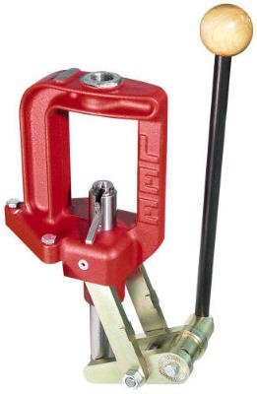
First of all, you will need a stout iron or steel frame single stage reloading press with a head that’s threaded to accept standard 7/8-14 thread reloading dies and standard snap-in shell holders. This includes many commonly used reloading presses out there today. I have my V-2.0 die set up in my Lee Classic Cast Iron Single Stage Press which provides enough strength and leverage to swag my slugs. There are a few presses that aren’t suitable out there such as some of the light weight aluminum framed units, and most of the turret and progressive multi-stage presses, which aren’t designed to take loads beyond that used for handgun cartridges with carbide reloading dies. Swaging slugs with this die will put about as much strain on the press and require about as much effort as full length sizing of heavy belted magnum rifle brass. The 375 H&H cartridge definitely comes to mind. Still, it doesn’t take a massive supper tough monster press and herculean effort like the 50-BMG cartridge requires

Secondly, you will need to get your hands on some pure or at least very soft pure-ish lead. You can use cut lengths of 3/8” or 5/16” lead wire like many swag cores from for jacketed rifle and pistol bullets but cut length becomes super critical. This is due to the fact that this die design, mainly due to its two part body held together with a coupler in the middle, doesn’t have a bleed off hole for excess lead. Rather, excess lead bleeds off backwards down the gap between the swag punch and die body forming a paper thin second skirt on the slug; more on that later. Long story short; trying to swag slugs from cut lengths of lead wire that are over weight by more then about 5 grains becomes very problematic and it is difficult to cut lengths of lead wire that precisely – at least it is for me. Maybe there are those out there that are far more experienced in swaging then I am and have no problem cutting cores from lead wire with that precision, to them I say have at it.
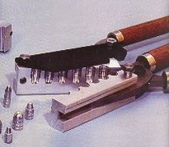
For the rest of us the best method I have found to produce cores to swag slugs from is to cast them in a multi cavity mold. For the hollow base, foster style slugs produced from this die you want to use a mold that’s suppose to make bullets in the 120 to 140 grain range according to the mold companies description of the mold. When you cast from pure lead they will come out at least 5 grains heavier. Molds intended to make heavy for caliber 9mm pistol bullets or light for caliber 38-spl/357-mag revolver bullets are a good place to start looking. For the attached base-wad slugs, made with the second swag punch nose form, molds for 40-S&W pistol bullets are usually about right producing pure lead cores between 170 and 190 grains (again the weight listed by the mold manufacturer will be lower because you’re casting with pure lead). Usually the cores you cast using such molds will come out wrinkled and not fully filled out completely because they weren’t designed to be used with pure lead. Pay it no mind and just cast for quantity running your casting pot and mold hot. The variance in weight as a result is usually less then 5 grains and you just set the swag die slightly tight and it will easily bleed off the excess couple grains from the heavier cores. The Lee “tumble lube” style molds will produce a little better looking slug then bullet molds with conventional style lube grooves. Better yet, take a multi-cavity mold designed to produce small diameter, short, light weight bullets such as molds intended to produce bullets for 32-caliber pistols. Use a drill press with depth set stop and a drill bit with a slightly larger diameter then the mold cavity to produce a mold that will make nice smooth sided cores to exactly the weight you desire.
Whatever method you choose for making your cores to swag into slugs don’t ever use hard lead alloys such as wheel weights, the various lead tin alloys such as 30:1 and 20:l or worse yet commercial hard ball alloy or type metal. These lead alloys are way, way to hard for the swaging die to handle without at least doubling the effort required, internal pressures, and strain on the die and press. The die is not designed to handle such abuse and will fail or wear out very quickly if subjected to such. Also, don’t attempt to swag a single slug from several different pieces of lead such as using lead balls or shot. This die does not operate at high enough pressures to bond several separate pieces of lead together during the swaging process.

Okay, so you’ve got your swaging die built, you’ve got an iron or steel frame single stage press to use it with, and you’ve got a way to make cores figured out. Now what? First, you need to lube your cores. Any of the lubes normally used for full length sizing of rifle brass are adequate. Follow the same procedure for lubing the cores as you would if they were brass cartridge cases. If it’s a spray-on lube take a handful of cores and put them in a paper bowel and spray them, shake them around a little and spray again. If it’s a finger tip applied sizing lube then apply it to each core with your finger tips before you intend to swag it into a slug just like you would if it were a brass cartridge case. Just like with a brass rifle case too much lube can put little bitty dents in the finished product from hydraulic force so don’t use way too much and goober them all up.
Next, securely screw your choice of swag punch into the punch base. Don’t be afraid to use a pair of pliers to get a little extra grip on the swag punch if needed so long as you grab only the lower, smaller diameter section of the swag punch with the teeth of the pliers. Now snap that assembly into the shell holder on your press. Then lower the lever on your press until the ram is as high as it will go and screw the assembled swag die into the top of the press until there is about a 1/8 of an inch gap between the bottom of the swag die and the top flat surface of the punch base. Now pick one of your cores that looks like it might be one of the slightly lighter weight ones and lift the lever on your press to lower the ram and set the core on the tip of the swag punch. If you’re doing hollow base, foster slugs and you made the tip of the swag punch almost flat except for a slight 3-degree angle like the blue prints show then it will balance on the tip of the swag die while you depress the lever and raise the ram up into the die. If you are making heads for the Brenneke style slugs which you will attach a base-wad to later with a screw and are using the swag punch with the narrow little pin on the tip, or if you made your own hollow base swag punch profile that’s round nosed, you will need to guide the core with your fingers until it enters the mouth of the die.
Fully depress the press lever. Unless you’re trying to swag cores that are too heavy of weight you shouldn’t feel the full resistance of a fully formed slug at this point. Lift the lever on the press slightly to lower the ram just a smidgen and then turn the swag die in about an eighth of a turn and then depress the press lever fully. Repeat backing off just a smidgen and turning the die in a little tighter at a time until you can feel the full resistance of a fully swaged slug and you just can’t quite depress the press lever all the way not even when pressing down very hard. Now back the die off just a notch so you can fully depress the press lever and get full ram stroke length and the final fill out of swaging the slug is at the highest leverage point of the press. Be careful with doing this on a press that “toggles over top dead center” and doesn’t have a hard stop point built into the mechanism at the top of the stroke just before the point of infinite leverage is reached.
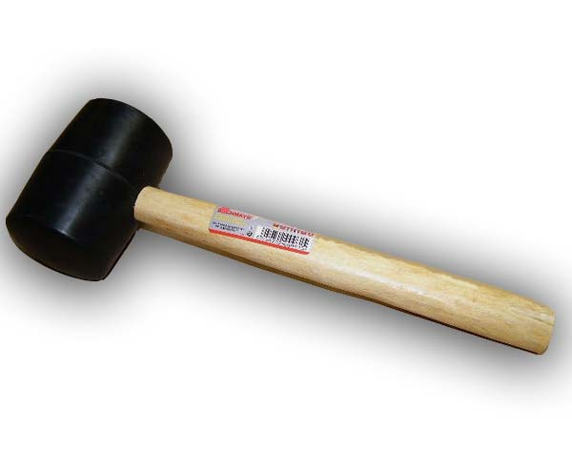
Okay, so now that the die has been adjusted it’s time to eject your first slug. Take a rubber headed mallet like the one shown on the right and give the Ejector Punch Knob a good wallop while the press lever is fully retracted and the press ram is full down. The swaged slug should drop out the bottom of the die. It will take a little bit of practice to know how hard of a hit to apply. If you have to apply more then one strike to eject a single slug you’re not hitting it hard enough, but at the same time you shouldn’t hit it so hard that the finished slug shoots out the bottom of the die and the ejector knob slams into the top of the die. The one strike ejection method with just enough force applied will produce slugs with the best shaped noses.
Once the slug has been ejected check it for complete fill out and if necessary tighten down the die just a little bit. You will notice two different “flaws” almost right away. Usually there is a paper thin slight second skirt on the bottom of the slug – this is how this die bleeds of excess lead and produces uniform weight slugs from swaging cores that are not nearly so uniform. It is easily trimmed off with a pen knife and discarded. Secondly you might notice some slight lead feathering on the nose where the extractor punch produces a slight seam. This is most easily removed by gently scraping with your finger nail. Trying to use a pen knife like on the bottom of the slug is over kill and usually results in cosmetic damage – although the slugs will still pattern nicely.

With a little bit of practice you can produce excellent quality slugs from this die in quantity. A few pictures:
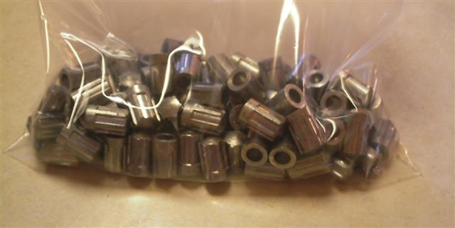
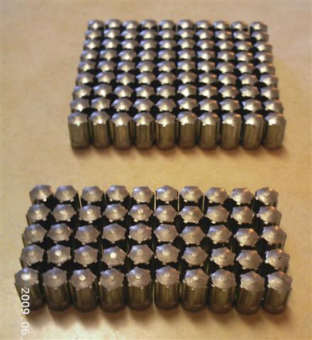

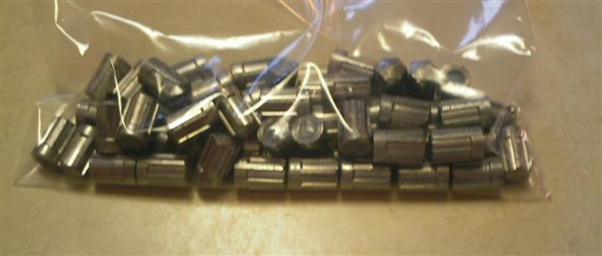

Once you have swaged your slugs you may wish to lubricate them before loading them which will significantly reduce leading. This can be done a variety of ways. One of the simplest and easiest methods is to use good old fashioned paste car wax; the stuff that comes in a round container with a little round application sponge in the lid. Simply get some wax on the application sponge and then lay the sponge down flat in the lid with the waxy side up and roll the slugs back and forth on top with your finger tips to apply a wax coating to their external surface. You can also use various tumble lube concoctions such as the stuff Lee sells as well a Johnsons Paste Wax or mixtures of the two just like a lot of guys use for lubing cast lead pistol bullets. Just be careful to tumble the slugs very gently because they are pure lead and can be easily dented and dinged if they are roughly tumbled together. If you are doing Brenneke style slugs with attached base wads assemble them first and then lube them nitro card base and all. Also, if you are going to fill up the hollow base, foster type slugs with a light weight solid filler like hot glue or epoxy to increase the structural stiffness of the slugs and make them penetrate more and expand less then do that before lubing as well.

Hand Loading and Shooting Slugs Made with This Die:

Built up Gas Seal, Nitro Card, & Cushion Wad Load Method:

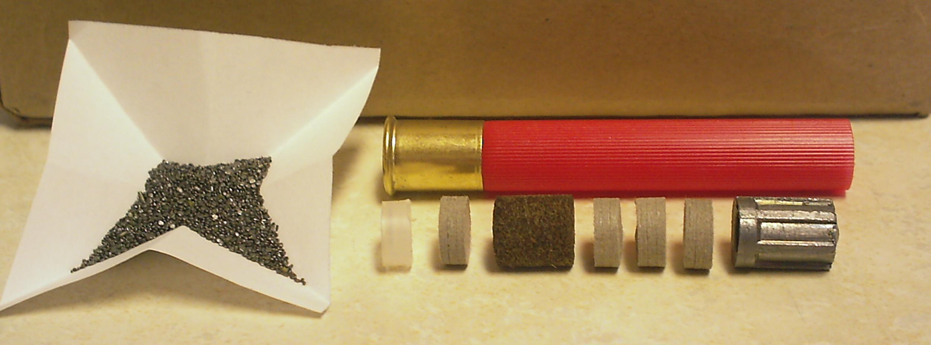

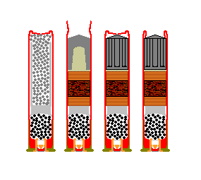
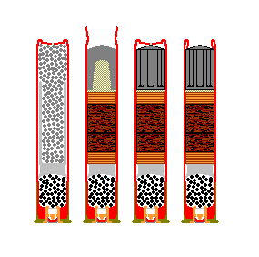
For the hollow base, foster style slugs the powder charge used should be about 150% (near max. load – work up to from about 120% start point) of what the average book load is for a ½ oz. lead shot loads using a powder that is normally used to load 410 shot loads (Lil-Gun, 2400, etc). Cap off the powder charge with a gas seal made from a 410 plastic shot wad with the petals cut off or a Gualandi stump wad cut in half to make two gas seals from each wad, followed by a single 1/8” thick nitro card. Then put in your cushion wad(s). Waxed felt or fiber wads are best. For loading hollow base fosters use a ¼” worth of cushion for a 2-1/2” load and ¾” worth of cushion for a 3" load followed by another1/8” thick nitro card and then the slug. Before the hull is crimped the whole load should be compressed with a pencil with the erasure side down on the slug nose with firm double hand pressure.
For the heavier attached base wad, Brenneke style slugs 3” hulls are strongly recommended to allow for a ½” of cushion material after the over powder gas seal and single 1/8” thick nitro card and then the slug, including its attached tail section, is loaded directly on top of the cushion material. A powder charge of about 130% worked up from a 100% charge is about right. If you do choose to load attached tail, Brenneke style slugs in 2-1/2” shells going above the suggested powder charge for a ½ oz of lead shot is not recommended because there isn’t room for any cushion wadding in the load and it’s all gas seal and nitro cards and thus very little if any “give” to the wad column. In loads for both slug styles it is useful to use shot buffer to provide a clean separation of the slug and wadding once they have left the barrel. For both slug types this can be as simple as a small pinch of shot buffer that’s put in to the load just before the slug to provide a slight barrier between the wadding and the slug and prevent them from sticking together. The hollow base, foster slug loads can sometimes be improved by completely filling the hollow base of the slug with shot buffer in the load. To accomplish this, the slug is flipped upside down and the hollow base filled up like a cup to slightly heaping with shot buffer. The hull is then held upside down and the slug with its base filled up with buffer pushed up into the hull with finger pressure until tight. The whole thing is then flipped back right side up and the load compressed and crimped as previously explained.

These built up gas seal, nitro card, & cushion wad loads are the most powerful loads I have been able to build to date with these slugs. The plastic gas seal so set up takes up only about 1/8" of wad column height and is effective. The two nitro cards one on top of the gas seal and the other just under the slug with the cushion wadding sandwiched in-between stiffen up the load in those two key areas of the wad column. I prefer to use waxed felt wads, as the cushion material serve two additional purposes beyond being a cushioning material. They are a very effective secondary gas seal and they help lube the barrel and thus keep leading and fouling down to a minimum.

''Remington'' Load Method:

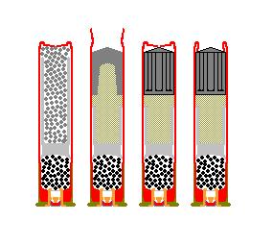
This load method as indicated by the name is basically a copy cat of how Remington loads their factory 410-bore 2-1/2” slugs. Basically you take a 2-1/2" hull. Put in a standard 1/2-oz shot load powder charge from a book load. Take a standard shot load plastic wad and snip off the front half of the petals and ram it home over the powder charge and then fill up the empty space with just enough shot buffer and then load the slug and crimp. It takes a little bit of experimenting to figure out exactly how much buffer to use to get the crimp height just right. But once you have got that ironed out it works fine. This method is good for producing accurate target loads in quantity without having to find and purchase any of the nitro or cushion wads the other method calls for. The unfortunate part of this loading method is that it seems to bring the pressure of the load up to 1/2-oz. lead shot payload levels even though the slug is significantly lighter. They are accurate but they aren’t power house loads. A form of the same method can also be used to load attached base-wad, Brenneke type slugs in 3” hulls but you need to purchase nitro cards to make those, so I don’t really see what the point would be. Even a wad column consisting of nitro cards entirely with no cushioning wads sandwiched in-between will allow higher powder charges and resulting higher velocity and energy levels at the same chamber pressures as loads which use a wad column made up entirely of shot-buffer which increases load pressures.
Shooting & Terminal Performance:

These slugs, thanks to their soft pure or nearly pure lead construction and rifled body, can be fired in any shotgun choke up to and including full-choke. They will easily squeeze down if necessary to pass through a tight choke. Obviously accuracy is best with guns with very little or no choke constriction. Accuracy is also improved by lubing your slugs which limits barrel leading that is detrimental to accuracy. The fastest and most powerful load is not always the most accurate, if you intend to use these slugs to hunt a living critter you should have thoroughly range tested your intended slugs and loads before even thinking of pulling the trigger with a living creature in the sights. A load combination lacking accuracy on the range at worst could result in a little embarrassment and/or frustration. In the field the stakes are much higher – the 410-bore is not a power house, it is an expert’s gun, and thus requires practice and precision to make a clean and humane kill.

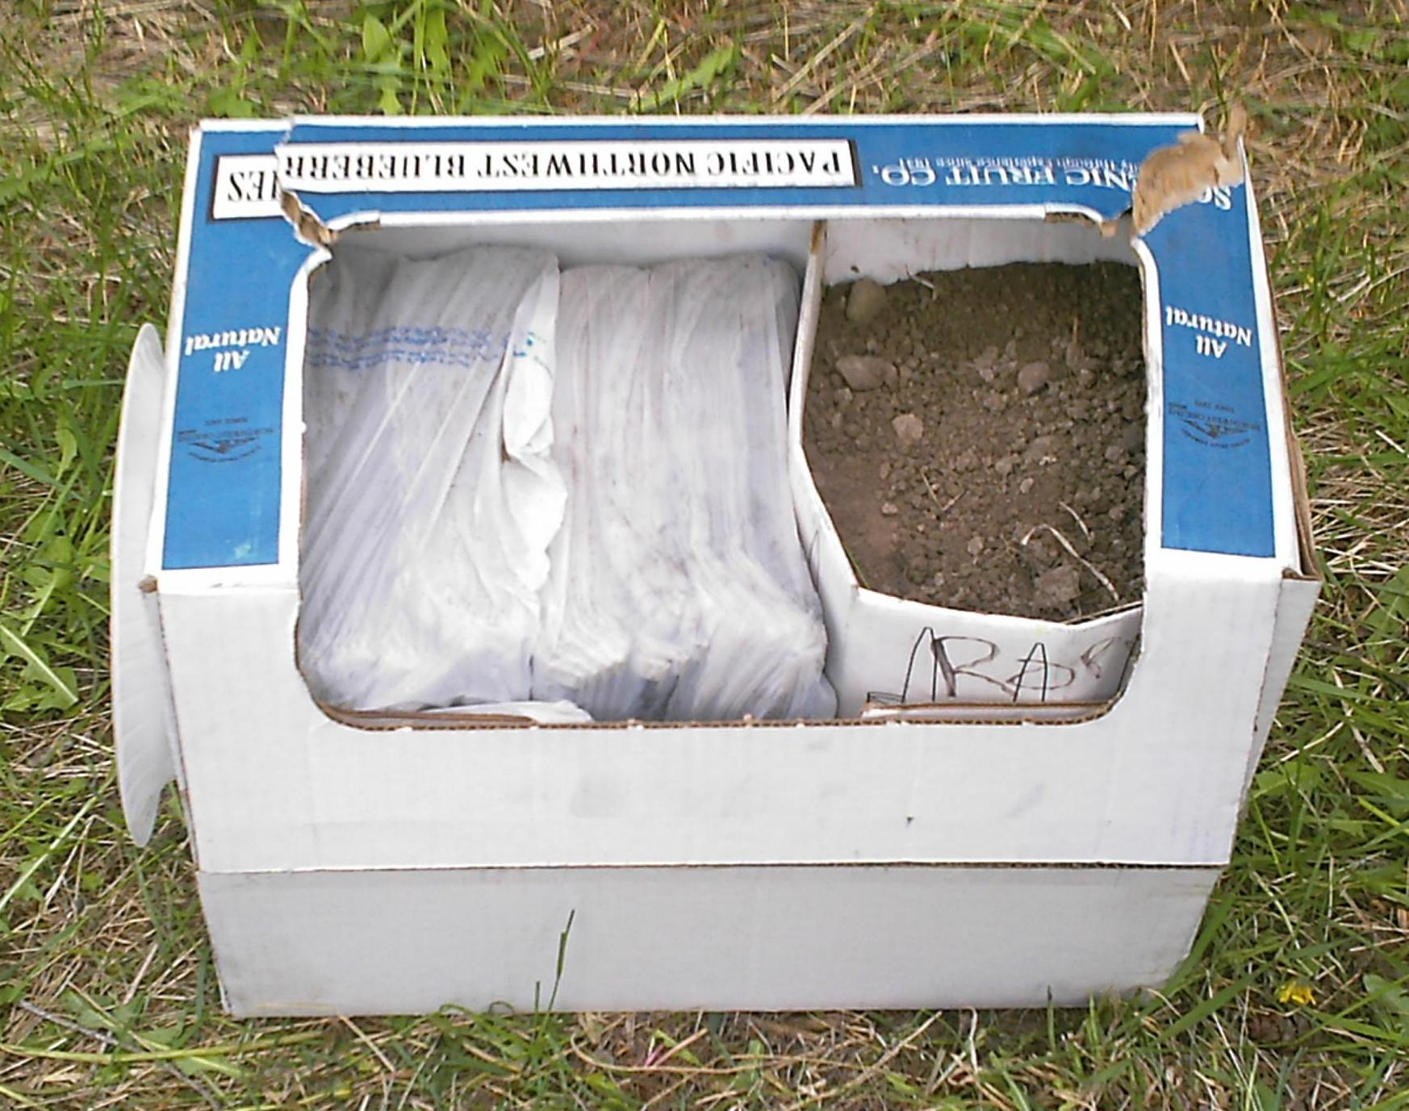
For those who might consider using these slugs for hunting live game and not just punching holes in paper, the following limited testing of the terminal performance of the hollow base, foster slugs should be of interest. First a test target was constructed using an old cardboard box. Two bunks of wet newspaper 6” inches thick and wrapped in plastic shopping bags were placed inside the box and the rest of the empty space filled up with a smaller box filled with dirt. Then from a distance of fifty yards five rounds were fired at the test target. One shot penetrated the target box but passed just barely above the test medium and thus was lost, but the other four buried themselves inside the layers of wet newspaper.
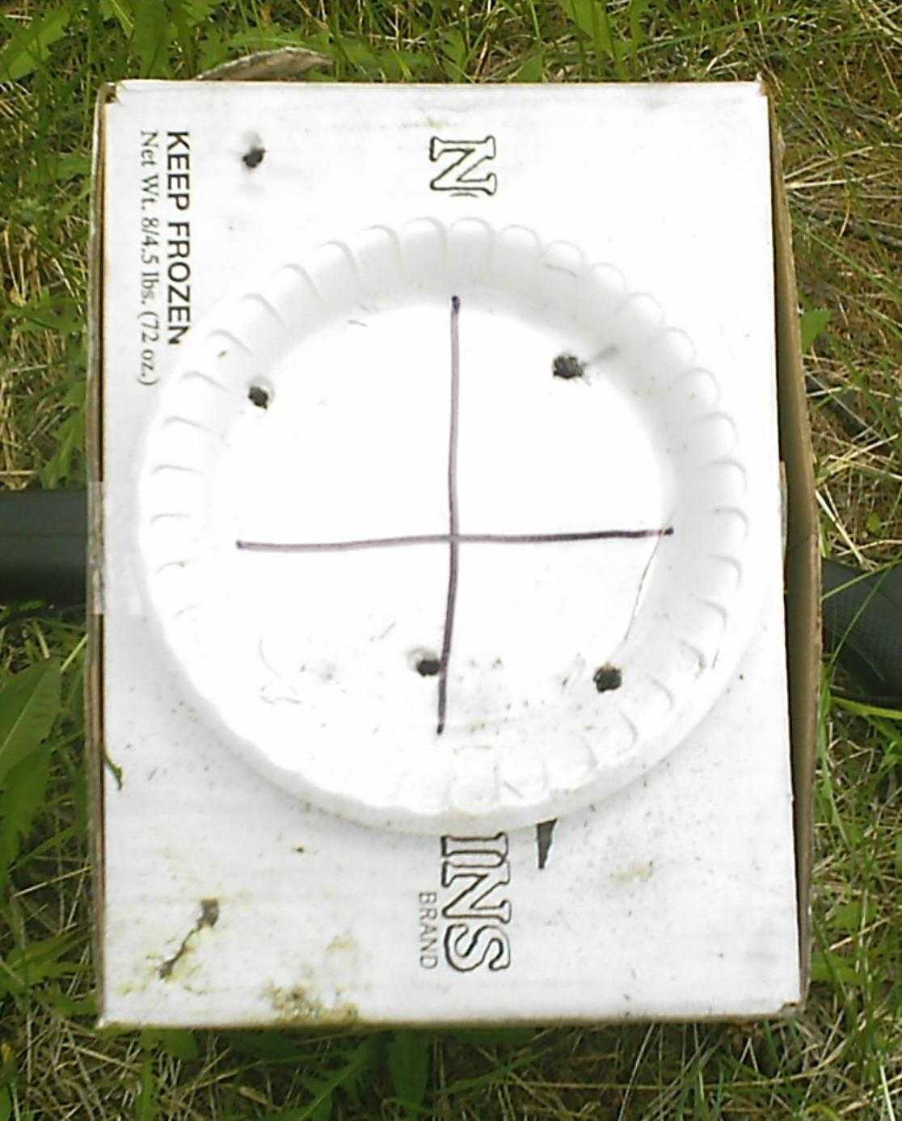

The group as seen is not a single pattern. The two shots on the right were fired from the test gun with a cylinder choke tube in place and the three shots to the left were fired with the full choke tube in place. What you are seeing is mainly vertical stringing which was a problem I was having back then with the particular load combination I was using. The upper left had shot is the one which passed above the test medium.

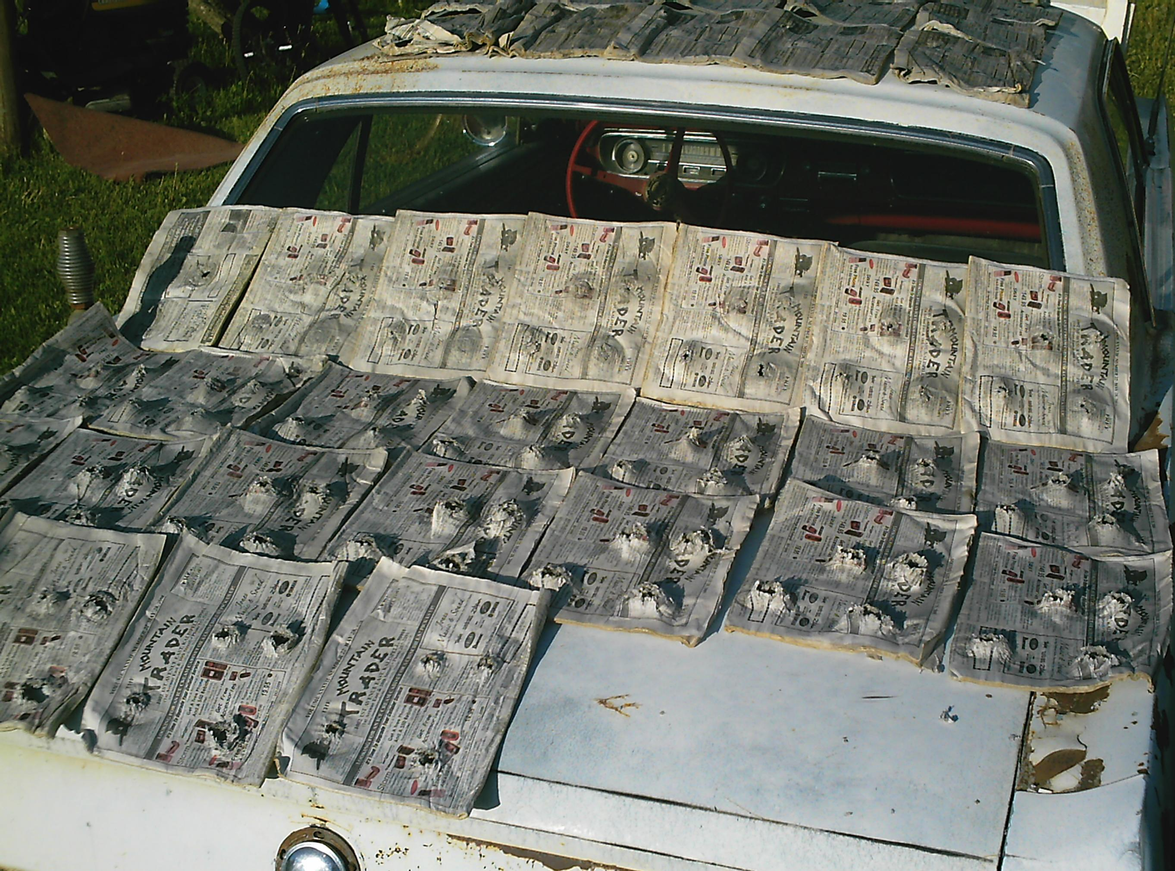
With this particular load combination, which was not a maximum power load, the average penetration depth of the slugs in wet newspaper was 6 inches. One of the slugs penetrated all the way through the first 6” bunk of newspaper, penetrated the plastic bag membrane, and then buried itself in the first few layers of the second bunk of wet newspaper. The other three slugs were found in the last layer of the first bunk bulging out the backside of the bunk.
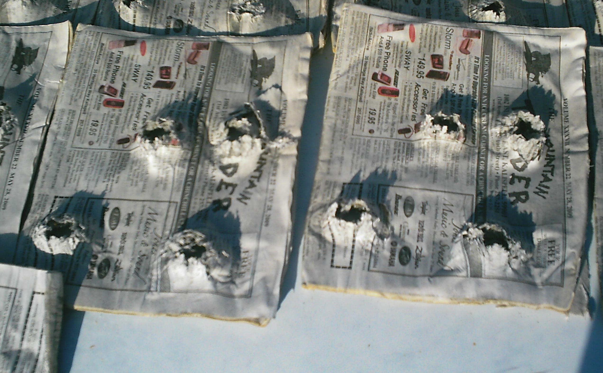

I believe if it were not for the plastic bags which obviously acted as a tough flexible membrane not unlike an animal’s hide all four of the slugs would have penetrated into the first few layers of the second bunk of wet newspaper.
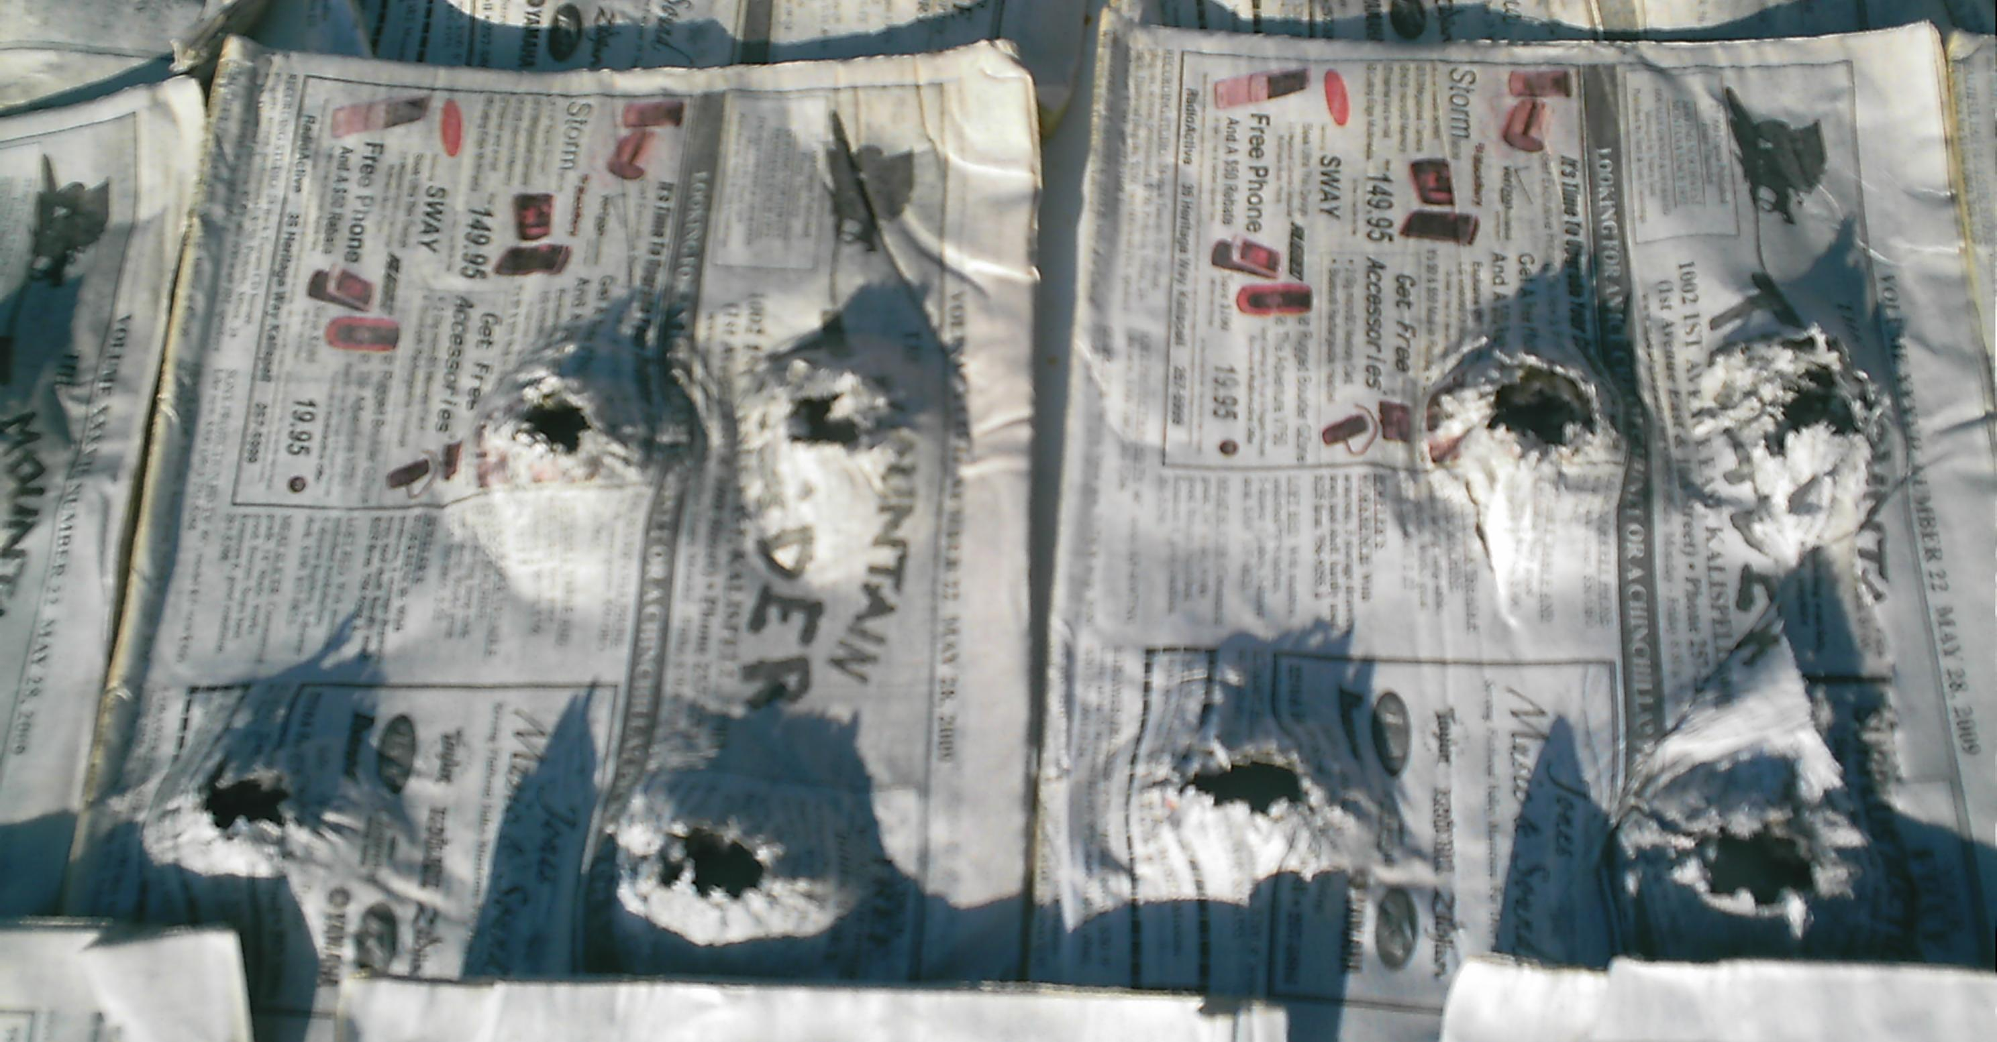
The results I got are not unlike finding ones bullet or slug just under the hide of a game animal on the side opposite the entrance wound after taking a broad side chest shot.
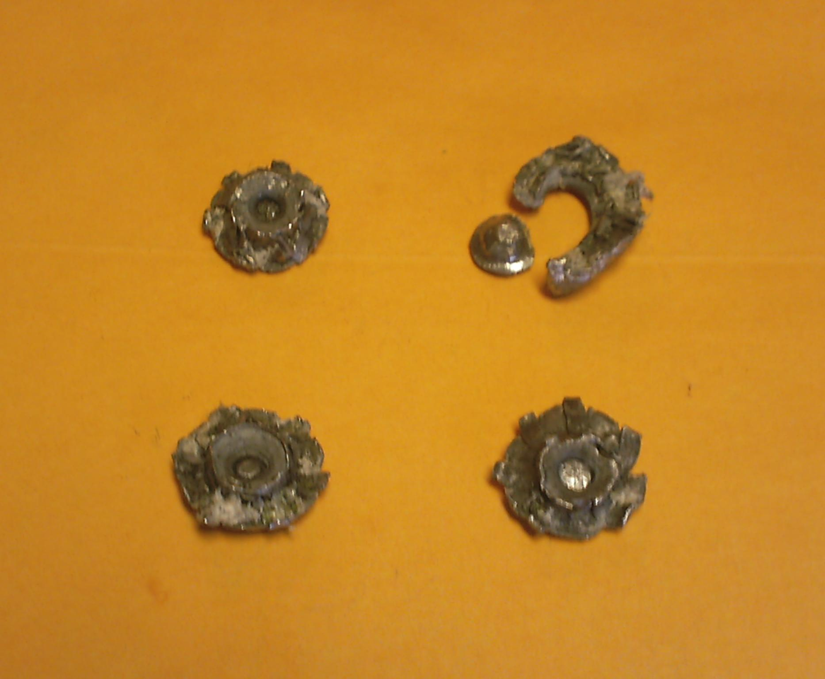

I should note that bunks of wet newspaper are a far tougher medium then animal flesh, so bullets and slugs will usually penetrate three to four times deeper on a living creature then they will in wet newspaper bunks. All four slugs mushroomed to between 0.7 & 0.8 inches diameter thus nearly doubling in frontal area. Weight retention for the three test slugs that held together was nearly 100% and the one that broke apart still maintained over 90% of it’s weight in the two main chunks which were found together in the orientation and spacing that I lined up for the photo. The smaller nose chunk penetrated a half newspaper layer deeper then the main ring.

In conclusion, I would not hesitate to use these slugs on any thin skinned, light boned critter up to and including most species of North American deer – provided the range was short and I was confident I could place the little slug in the “boiler room”. That is my conclusion. You must build your own about the terminal effectiveness and knock down power of the slugs produced from this die design from what I have presented and by all means please do your own testing as well. I have not yet tested the attached base wad, Brenneke style slugs produced from this die for terminal performance but I imagine they will outperform the fosters at least in penetration depth.

